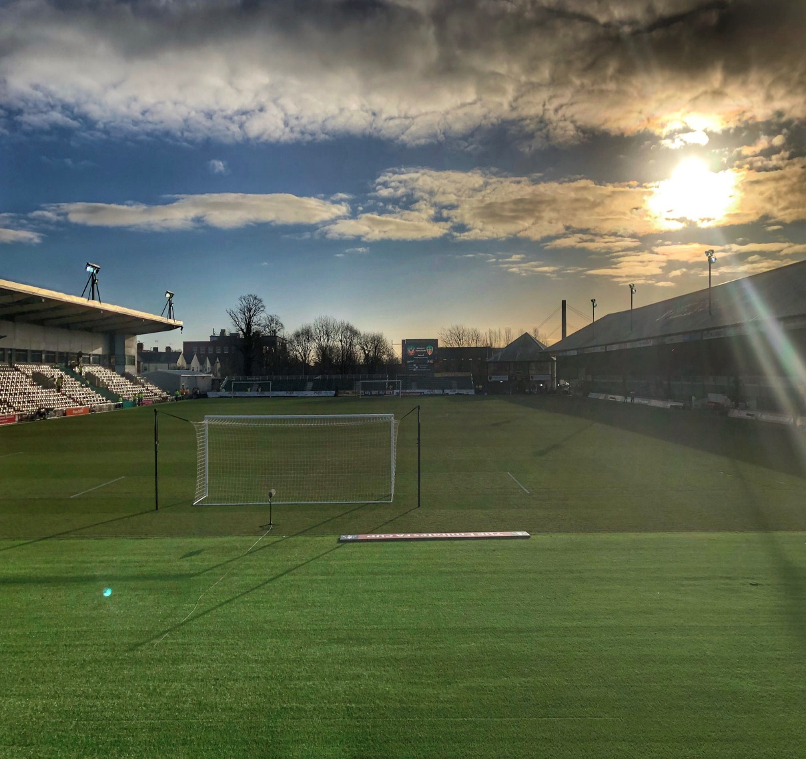
Address:
Rodney Parade Stadium,
Rodney Road,
Newport.
NP19 0UU

Contact Number:
01633 670690

VISITING RODNEY PARADE INFORMATION

Introduction
To ensure that Match Days run as smooth as possible for all parties involved, we ask that you review the following information regarding your visit.
If you have any queries, please do not hesitate to get in touch.

Stadium Contact Information
Ian Wilkinson  Safety Officer & Operations  Ian.wilkinson@dragonswales.wales | Ben Lucey  Operations  Ben.lucey@dragonswales.wales

Away Team Travel

TEAM BUS - Team buses should use the post code NP19 0AS. This postcode will direct the bus the main gate to park.
Under no circumstances should the Bus travel down Rodney Road.

KIT VAN – There is a space reserved for an away kit van within the changing rooms facility. The changing rooms are situated at Gate One, on Rodney Road (NP19 OAX).

PLAYERS ARRIVAL – Players arriving individually by car should utilise Maindee School Car Park (NP19 0NW). A list of players wishing to arrive by Car should be provided in advance of the fixture.

SUPPORTERS BUSES – Newport Transport facilitate a parking facility for supporter’s coaches, a 2 minute walk from Rodney Parade.
To book: sales@newporttransport.co.uk - Tel: 01633 670563

Please provide an estimated arrival time for both the team bus and kit van so that we can ensure that a reception is organised to assist.

Warm Up & Cool Downs

In order to protect the pitch to ensure that the field of play is at the highest standard for all teams visiting Rodney Parade, all players and officials should abide by the following procedures before and after a Match. The stadium opts to abide by EFL regulations for all fixtures:

PRE & POST MATCH - Only players named in the match day squad are permitted on the pitch to warm up/ warm down.
Pre-Match warmups can only take place between 45 minutes and 10 minutes prior to kick off.
Pre-match warmups should last no longer than 30 minutes while post-match warm downs should last no longer than 15 minutes.

EXERCISE AREAS - All speed and stamina work shall be undertaken off the pitch and on the 4G surface around the perimeter of the pitch or as otherwise directed by the Ground Staff.

Other Stadium Information

Please assist our Match Day Operation by communicating the following information to supporters:
CASHLESS BARS - The venue strives to deliver the best possible fan experience at our iconic home, so cashless bars – including Rodney’s Bar – are now in operation.
All major contactless debit and credit cards will be accepted, with chip and pin applying for purchases over £30.
Mobile payments, including Apple Pay and Google Pay will also be able to be used.

